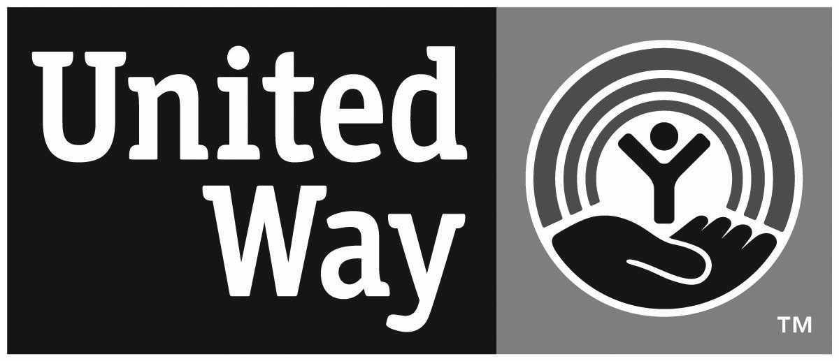 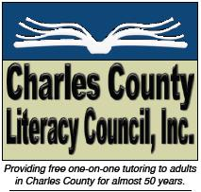 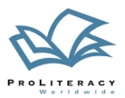

# **PO Box 2672, La Plata, MD 20646**

**301-934-6488**

**Website:** [**http://www.charlescountyliteracy.org**](http://www.charlescountyliteracy.org/) **Email:** [**charlescountyliteracy@comcast.net**](mailto:charlescountyliteracy@comcast.net)

Charles County Literacy Council is a non-profit tax-exempt organization under IR Code §501(c)(3)

Federal Tax ID Number: 52-1525917. MCC #521525917. CFC #77322.

TUTOR TRAINING WORKSHOP REGISTRATION FORM

COMPLETE AND RETURN TO ABOVE MAILING, ALONG WITH REGISTRATION FEE,   
OR SUBMIT VIA EMAIL

You must be 18 or older to register.

## Thursday, January 9, 2025 -- from 6:30 – 8:30 pm via Zoom

## Saturday, January 11, 2025 from 8:30 am – 3:30 pm

## (In conference room at United Way House (10250 La Plata Rd. (Rt. 488))

***Additional 4 hours of reading materials training are required prior to workshop.***

***Registration required.***

***Instructions on homework and materials will be provided after registration is received.***

**Deadline to Register: Two Weeks Before Scheduled Workshop Date**

**Registration Fee - $30 (Return with registration)   
OR Submit registration fee online using the** [**Donate button**](https://charlescountyliteracy.org/donate/) **(This helps defray our workshop per tutor student cost of $65+) Thank you!**

**Please register me for the workshop. I understand this registration will guarantee me a place in the class. I also understand that in order to become a tutor, I must complete online training prior to the workshop and abide by the tutor volunteer agreement.**

NAME _____________________________________

ADDRESS _________________________________

CITY ____________________ ZIP ______________

E-MAIL ____________________________________

PHONE ____________________________________

BIRTHDATE_________________________________